**Nature of Organization**

**Organization**

* Deliberate arrangement of people to accomplish some specific purpose (that individuals independently could not accomplish alone).
* Key points
  + Individuals
    - Employees
    - Management
  + Serves a certain function within the company
    - Based on the Goals and Objectives
    - Getting the Job done.

**Characteristics of an Organization**

* **Have a distinct purpose** 
  + The organization has its intended objectives and targets it would like to meet and gain.
* **Composed of people**
  + Comprises of different individuals who work in various parts and maybe from different backgrounds.
* **Have a deliberate structure**
  + Determines the manner and. extent to which roles, powers and responsibilities are delegated and coordinated and. how information flows between levels of management.

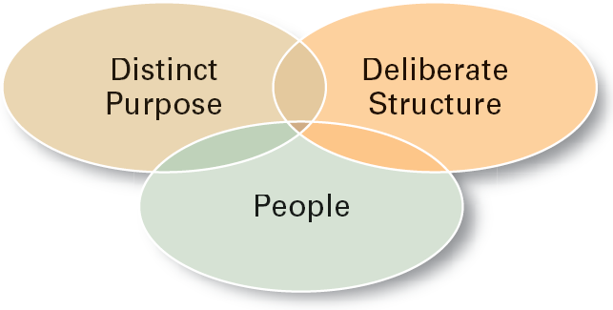

**Key Elements of an Organization**

* **Structure** 
  + Departmentalization, chain of command, span of control, centralization or decentralization, work specialization and the degree of formalization.
* **Technology**
  + Looks at work processes, equipment’s and methods.
* **People** 
  + Looks to the overall behavioral aspect that covers the attitude, what they want and how they look at things from their point of view.

**Organizational Vision and Mission**

|  |  |
| --- | --- |
| **Organizational Vision** | **Organizational Mission** |
| A Vision Statement describes the desired future position of the company. | A Mission Statement defines the company's business, its objectives and its approach to reach those objectives. |
| **Example**  Our vision is to create a better every-day life for many people.” – IKEA. | **Example**   * Life is Good: To spread the power of optimism. * Sweet green: To inspire healthier communities by connecting people to real food. |

Elements of Mission and Vision Statements are often combined to provide a statement of the company's purposes, goals and values.

**The Key Elements of a Mission Statement**

* Value – What is the value of the business to both customers and employees?
* Inspiration – Why should people want to work for the company?
* Plausibility – Make it sound reasonable
* Specificity – Tie it back to the business

**Tips for Creating an Effective Mission Statement**

* **Do keep it short and concise.**

Sum up the company’s mission in just a few sentences.

* **Don’t write an essay.**

That is not the purpose of this brand building tool. You want the mission statement to be tethered to the brand and that means it must be memorable. Long drawn out prose is rarely memorable.

* **Do think long-term.**

The mission statement is an investment in your company’s future, so keep it open enough to reflect your long-term goals.

* **Don’t make it too limiting.**

We want to provide the best products ever to the town of Elmwood. Do you only see the business selling to the residents of one small town or do you hope to expand at some point?

* **Do find out what your employees think of the mission statement.**

This is a tool designed with them in mind, too, so get their opinion. Ask how they would improve it and what they dislike about it.

* **Don’t be afraid to change it.**

Things change in the business world. If the mission statement no longer represents the company, it is time for a rewrite.

**How to come up with a vision statement**

1. Project five to ten years into the future.
2. Determine your purpose and position as an organization.
3. Describe what success looks like in your operations.
4. Consider your company type and structure.
5. Reference your competitors or create an analogy.
6. Describe a measurable goal.

**Stake Holders**

* Is anyone or any group with an interest in the organisation/industry.

**Stake Holder Types**

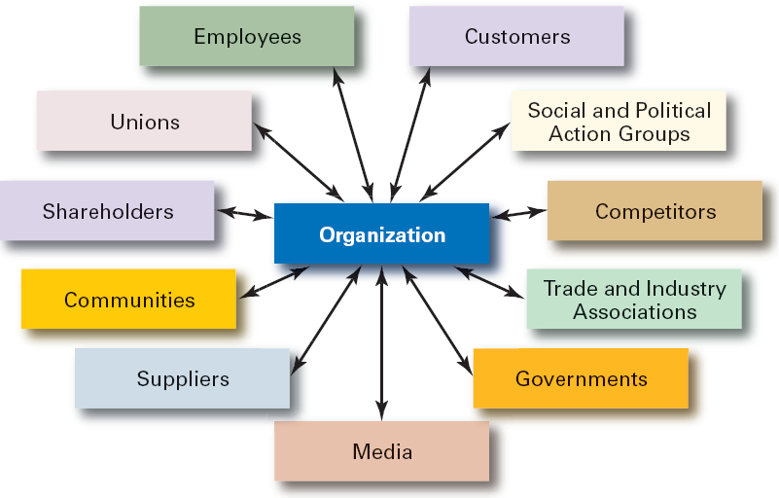

**Internal & External Stake holders**

|  |  |
| --- | --- |
| Internal | External |
| those who are ‘members’ of the business organization | are groups outside a business or people who don't work inside the business but are affected in some way by the decisions and actions of the business. |

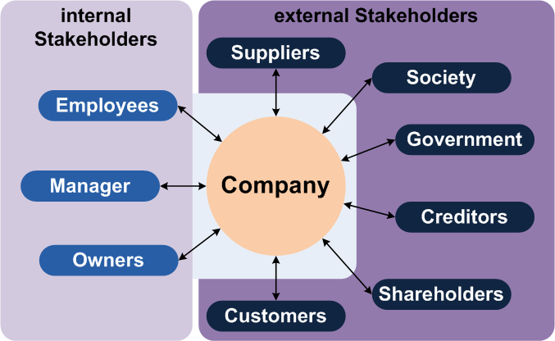

**Chain of command**

Refers to a company's hierarchy of reporting relationships – from the bottom to the top of an organization, who must answer to whom. The chain of command not only establishes accountability, it lays out a company's lines of authority and decision-making power.

**Span of control**

The area of activity and number of functions, people, or things for which an individual or organization is responsible.

**Work specialisation**

Also known as division of labor, refers to the degree to which tasks necessary to achieve organizational objectives is divided into various jobs. Work specialization allow managers to break complex tasks into smaller, more precise tasks that individual employees can complete.

**Formalization**

Formalization in organizational structure is a process in which managers specify (in writing), procedures, rules and responsibilities for the individual employees, organizational units, groups, teams and the organization as a whole, which leads to the development of processes, relationships, and operating procedures.

**Perceptions**

This can be described as a process by which people regard, analyze, retrieve and react to any kind of information from the environment.

**Job Redesign**

Job Redesign is basically a process of 'restructuring' the elements of a job (like tasks, duties and responsibilities). It is usually done to the job more interesting, exciting, encouraging and inspiring for the employees.

